- General
Submit a complete, detailed and signed Progress Schedule to the Engineer within seven (7) calendar days after Award and prior to starting work. The Engineer for this project is as follows:

Sam Fitzer, P.E.
The Road Commission for Oakland County
31001 Lahser Road
Beverly Hills, MI 48025
248-202-9087
sfitzer@rcoc.org

The Progress Schedule shall include, as a minimum, the controlling work items for the completion of the project and the planned dates that these work items will be controlling operations. When specified in the bidding proposal, the date the project is to be opened to traffic as well as the final project completion date shall also be included in the project schedule. If the Bidding Proposal specifies other controlling dates, these shall also be included in the Progress Schedule.

After award and prior to the start of work, the Contractor must attend a preconstruction meeting with the Engineer. The schedule for this meeting will be determined by the Engineer. The Engineer will arrange the day, time and place for the preconstruction meeting. The named subcontractor(s) for designated and/or Specialty Items, as shown in the proposal, are recommended to be at the preconstruction meeting if such items materially affect the work schedule.

Start work within 10 days of Award. However, site work and implementation of the road closure shall not commence until on or after [DATE] unless otherwise agreed upon by the Engineer. In no case, shall any work be commenced prior to receipt of formal Notice of Award by the Department.

If the Contractor is required to perform further action for any permits as outlined in the Special Provision for Permits and Inspection Fees, the Contractor is required to complete the necessary actions in advance of the start of onsite project work activities. The Contractor will not be authorized to start onsite work without acquisition of all necessary permits.

The Contractor shall be expected to mobilize sufficient labor and equipment to complete the project within the specified time frames.

The Contractor may be required to meet with Department representatives for a post-construction review meeting, as directed by the Engineer. The Engineer will schedule the meeting.

###Local Let Only – REMOVE IF A FED AID MDOT LET PROJECT
Failure on the part of the Contractor to carry out the provisions of this Progress Clause may be considered sufficient cause to prevent bidding on future projects.
###Local Let Only – REMOVE IF A FED AID MDOT LET PROJECT

Expedited Schedule Language – Remove if not used.
- Expedited Schedule
This project is on an expedited schedule. The Contractor is expected to mobilize sufficient labor resources and equipment and to work the required overtime to maintain the expedited schedule. The Contractor shall include any costs associated with maintaining the expedited schedule in the Bid Items for work, as it will not be paid separately.

Unless specific pay items are provided in the contract, any extra costs incurred by the Contractor due to cold-weather protection, winter grading, sufficient manpower and equipment necessary to maintain the expedited schedule, and/or meet the final completion date, and any overtime will not be paid for separately, but will be included in payment of other contract items.
## Expedited Schedule Language – Remove if not used. ##

LID Language – Remove if not used.
- Locked Incentive Date
This project has a Locked Incentive Date (LID). Details of the incentive are further defined in the Special Provision for Locked Incentive Date located elsewhere in this Proposal. Deadlines associated with the LID are separate and unique from the deadlines outlined below.

Road Closure Language – Remove if not used.
- Road Closure
The project Special Provision for Maintenance of Traffic includes a proposed road closure that will be required in order to complete the project. The Board of County Road Commissioners for the County of Oakland (Board) must approve the road closure request at a regularly scheduled Board Meeting prior to implementation of a road closure. Failure by the Contractor to provide timely notice of anticipated road closure dates to the Engineer will not be a basis of claim for costs or extension of time to complete the project.

In order to obtain the necessary Board approval, the Contractor must provide written notice to the Engineer by the Road Closure Notification Deadline date for the Board meeting that precedes the requested closure date. See the RCOC Board Meeting Date calendar contained in this document for Board meeting dates and the required Road Closure Notification Deadlines.

The road closures and detours can only be implemented once and shall not be reinstated for the remainder of the project duration. The road shall be sufficiently repaired and in suitable condition to be designated “Approved for Traffic” and shall be Opened to Traffic as directed by the Engineer before the time limits stated below. The “Approved for Traffic” condition shall be as defined in the Contract and the roadway or portions thereof shall be Opened to Traffic in accordance with Section 107.21 of the MDOT 2020 Standard Specifications for Construction. Liquidated damages will be assessed to the Contractor for closure durations that exceed those stated below:

  - Road Closure for Stage 1 – This closure shall not last more than X calendar days.
  - Road Closure for Stage 2 – This closure shall not last more than X calendar days.
  - Road Closure for Stage 3 – This closure shall not last more than X calendar days.
## Road Closure Language – Remove if not used. ##

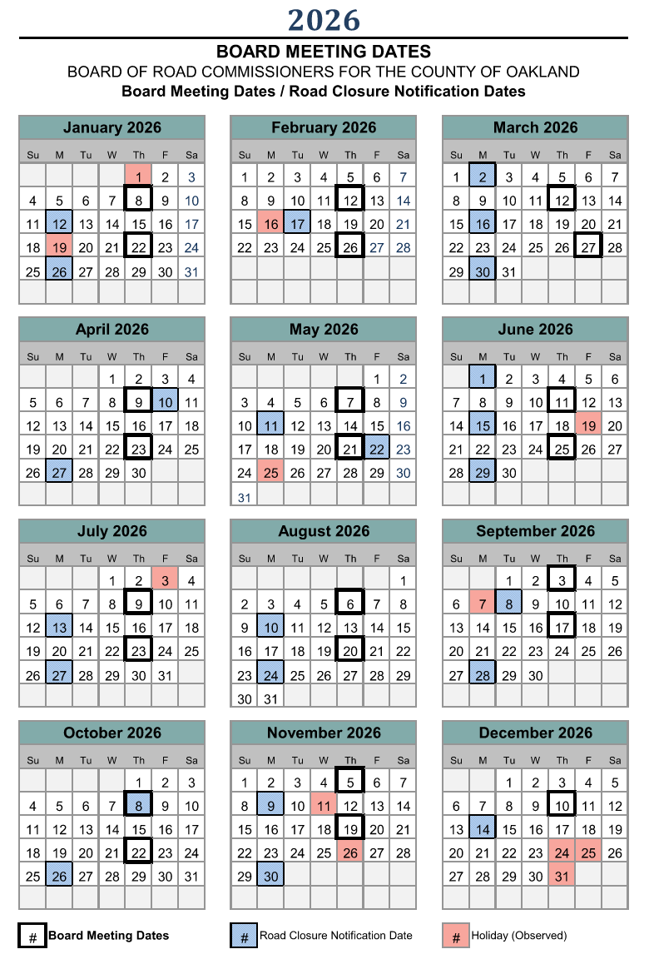

- Milestones

Tree removals limitations for trees that may contain habitat for bats. – Remove if not used
  - Tree Removal Limitations
The Project is located within the habitat range for protected bat species. Tree removals shall be completed between October 1, 20XX and March 31, 20XX.
## Tree removals limitations for trees that may contain habitat for bats. – Remove if not used ##

  - Open to Traffic
The project shall be sufficiently complete and in suitable condition to be designated “Approved for Traffic” and shall be Opened to Traffic as directed by the Engineer, on or before [Date]. The “Approved for Traffic” condition shall be as defined in the Contract documents.

  - Entire Project and Restoration excluding Delayed Acceptance Items
Other than the delayed acceptance requirements for Raised Pavement Markers and Turf Establishment, the entire project, including the placement of all permanent soil erosion control items shall be completed on or before [Date].

Cultivating Trees Language – Remove if not used
  - Entire Project and Restoration
The entire project, including placement of all final restoration items, Turf Establishment items and delayed acceptance requirements, but excluding watering and cultivating of trees, shall be completed on or before [Date].

The entire project, including watering and cultivating of trees, shall be completed on or before [Date].
## Cultivating Trees Language – Remove if not used ##

  - Entire Project Including Delayed Acceptance Items.
The entire project, including delayed acceptance requirements for Raised Pavement Markers and Turf Establishment, shall be completed on or before [Date].

- Liquidated damages for failure to meet Milestones
Failure on the part of the Contractor to meet each of the above Milestones by the date specified shall result in the assessment of Liquidated Damages against the Contractor as provided in Section 108.10, Liquidated Damages, of the MDOT 2020 Standard Specifications for Construction.

Liquidated damages will be assessed separately, simultaneously and concurrently for failure to meet Milestone dates as specified above. Liquidated Damages will continue to be assessed for each calendar day or portion of a day that this work remains incomplete even if these days extend beyond the normal Seasonal Suspension period of [Date].

Assessment of Liquidated Damages and/or contract adjustments applies to hourly/daily restrictions included in the Maintaining Traffic Special Provision.

Traffic Signal work beyond Nov 15 – Remove if not used
- Suspension of Seasonal Suspension for Traffic Signal Work
The seasonal suspension from November 15 through April 15 is hereby suspended for above ground signal work.
## Traffic Signal work beyond Nov 15 – Remove if not used ##

- Work Day, Hour, And Other Work Restrictions Imposed By Local Communities
The work hours described may be modified or changed by the Engineer due to Holidays, Special Events, or Traffic Volumes.

  - Contractors operations shall be limited by local municipality work time, noise, and dust ordinance unless approved by the local municipality and the Engineer in writing.

    - City of XXX
List times here…

    - Township of XXX
List times here….

  - No work or lane closures, unless approved by the Engineer, shall be performed during:

2025: New Year’s Day (from 3:00 pm Monday, Dec 30, 2024 to 6:00 am Thursday, Jan 2nd), Memorial Day (from 3:00 pm Friday, May 23rd – 6:00 am Tuesday, May 27th), 4th of July (from 3:00 pm Thursday, July 3rd – 6:00 am Monday, July 7th) or Labor Day (from 3:00 pm Friday, August 29th – 6:00 am Tuesday, September 2nd), Thanksgiving Day (from 3:00 pm Wednesday, November 26th to 6:00 am Monday, December 1st), Christmas Day (from 3:00 pm Tuesday, December 23rd to 6:00 am Friday, December 26th), and no work on the following holidays: Martin Luther King Jr. Day (January 20); President’s Day (February 17), Good Friday (April 18), Veteran’s Day (November 11).

2026: New Year’s Day (from 3:00 pm Tuesday, Dec 30, 2025 to 6:00 am Friday, Jan 2nd), Memorial Day (from 3:00 pm Friday, May 22th – 6:00 am Tuesday, May 26th), 4th of July (from 3:00 pm Thursday, July 2nd – 6:00 am Monday, July 6th), Labor Day (from 3:00 pm Friday, September 4th – 6:00 am Tuesday, September 8th), Thanksgiving Day (from 3:00 pm Wednesday, November 25th to 6:00 am Monday, November 30th), Christmas Day (from 3:00 pm Wednesday, December 23rd to 6:00 am Monday, December 28th), and no work on the following holidays: Martin Luther King Jr. Day (January 19); President’s Day (February 16), Good Friday (April 3), Veteran’s Day (November 11).

2027: New Year’s Day (from 3:00 pm Wednesday, Dec 30, 2026 to 6:00 am Monday, Jan 4th), Memorial Day (from 3:00 pm Friday, May 28th – 6:00 am Tuesday, June 1st ), 4th of July (from 3:00 pm Friday, July 2nd – 6:00 am Tuesday, July 6th), Labor Day (from 3:00 pm Friday, September 3rd – 6:00 am Tuesday, September 7th ), Thanksgiving Day (from 3:00 pm Wednesday, November 24th to 6:00 am Monday, November 29th), Christmas Day (from 3:00 pm Thursday, December 23rd to 6:00 am Tuesday, December 28th), and no work on the following holidays: Martin Luther King Jr. Day (January 18); President’s Day (February 15), Good Friday (March 26), Veteran’s Day (November 11).

Additional lane or ramp closures other than those already in place will not be allowed during the following events unless otherwise approved by the Engineer:

    - Other events

    - Event name, dates and times.

